

Annual General Meeting of the League
Thursday 28 May 2026 7.30pm
Redland Church Meeting Rooms, Redland Green BS6 7HE

- Chairman’s Opening remarks

- Apologies for absence

- Minutes of AGM 27 May 2025

- Reports from Officers:

  - Match Secretary (Dave Tipper)
  - Grading Officer (Stuart Iles)
  - Recruitment and Publicity Officer (Jane Norton)
  - Junior Officers (Oli Stubbs, Jack Tye)
  - ECF Representative (John Paines)
  - Congress Report (Igor Doklestic)
  - Treasurer (Jerry Humphries)

- Adoption of the Accounts

- Trophies and Certificates

- Election of Officers

- Motions

- Other business

Item 6 2025-26Trophy Winners
Bristol Congress:
- Open: Zack Norris
- Major: Kas Coman
- Section 3: Miles Howells
- Section 4: Mauro Farina
Bristol Blitz 2026:Tom Shepherd
Bristol Rapid 2026:Oscar Garcia
Division 1:Downend and Fishponds A
Division 2: Bristol University A
Division 3:Yate and Sodbury A
Division 4:North Bristol A
Division 5:Yate and Sodbury B
Division 6:UWE A
Division 7: UWE B
Knock-out Cup Downend and Fishponds
Minor Knock-out Bath
Alan Ashby Silver Salver (for league player with most points for a single team) Will Austin
Alan Ashby U18 (for junior with most points for a single team)Selikem Amoako

Item 7 Election of Officers.

The following officers are standing for re-election
- Chair: Igor Doklestic
- President:George Miller
- Vice-President: James Meadows
- ECF Representative: John Paines
- General Secretary: Peter Marks
- Junior Officers: Jack Tye and Oli Stubbs.
- Match Secretary: Stuart Iles
- Recruitment & Publicity Officer: Jane Norton
- Webmaster: Dave Tipper

Additionally, the Committee proposes the following nominees:
- Treasurer: Ed Honey

Other roles:
- Congress Secretary
- Auditor (not LMC):Vacant

Nominations from the floor for any of these positions arepermissible.

Item 8 Motions

There are 2 motions included. Both proposed by Arnav Sud.

Motion 1: Introduction of rating difference as part of board order and playing strength rule.

Proposer: Arnav Sud

Seconded: Sam Day

Background
Clubs across the league are finding it increasingly difficult to field six-player teamson a consistent basis. Variations in player availability, club reorganisations, and evenoccasional closures, have made the current format unsustainable. In some cases,clubs are being forced to move players between divisions simply to meet teamquotas — a practice that, while understandable, compromises both fairness and theintegrity of the league. Some teams are able to play in Divisions 1-4 purely on thebasis of “quantity” than “quality”, leading to frustration amongst stronger players inthe lower half of the League, who miss out due to not having enough players in theirClub, or all being available at a given time.
Proposal
That the minimum team size for Divisions 1–4 be reduced from minimum six playersto minimum four players per team.
Rationale
- Sustainability: A 4-player structure is more achievable for clubs with fluctuating membership.
- Fairness: Reduces defaults and ensures results are decided over the board.
- Accessibility: Allows smaller clubs to participate fully without excessive recruitmentpressure.
- Integrity: Removes the need to shift players unethically between divisions.
- Proven Success: Similar 4-board formats operate successfully in the same league inlower divisions and some 4NCL competitions too. In fact, it will increase participation for bigger Clubs, for example a Club with 8 players available can field two teams rather than one, which is not the case with a 6 person team.
Conclusion
This proposal aims to protect participation, fairness, and long-term sustainability. A4-player minimum ensures that clubs of all sizes can continue to compete ethicallyand consistently, strengthening the league as a whole. It also ensures that Chessplayers are able to concentrate on the game itself rather than organising themselvesfor meeting seasonal demand.

Motion2: Proposal to Update the League Ranking System

Proposer: Arnav Sud

Seconded: Sam Day

- Introduction: Fairness and Game Theory (Nash Equilibrium if you like)
Fairness in competitive settings requires that teams are rewarded in proportion to their performance and that the ranking system does not inadvertently encourage strategic underperformance. Game theory evaluates whether a system is “incentive-compatible,” meaning that the optimal strategy for all teams is always to give full effort.
Ranking systems that contain thresholds or loopholes can unintentionally reward risk avoidance or passive play once a goal has been secured. Chess leagues commonly use match-based scoring, treating the match result as the primary outcome, or board-based scoring, which evaluates the totality of performance across all boards.
From a fairness and game-theory standpoint, systems that reward every unit of performance tend to offer more accurate rankings and better incentives. This proposal compares the two methods and recommends a revised system for adoption.
- Current League Results Under the Match-Point System (2–1–0)
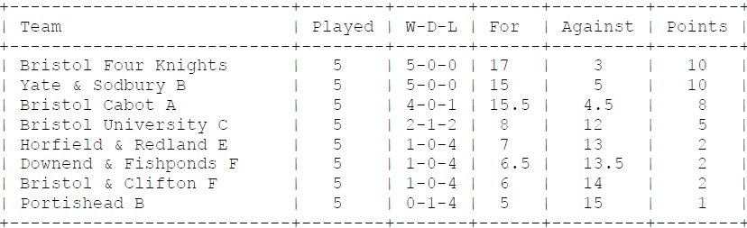
- Results Calculated by Board Difference (Normalised For – Against)
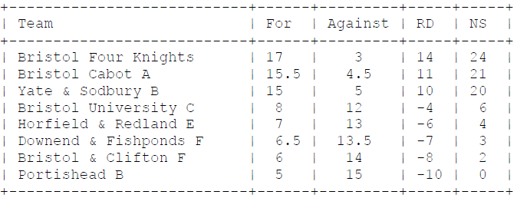
RD = Raw Difference, NS = Normalised Score
Normalisation is simply adding the lowest score to each score, so as to avoid negative scores,in this case (minus) 10.

- Pros and Cons of the Match-Point System
Advantages
- Avoids excessive pressure to run up large winning margins against weaker teams.
Disadvantages
- Threshold effect: once a team secures enough points to win the match, extra wins giveno reward.
- Encourages draws or risk-averse play on remaining boards.
- Does not differentiate between narrow and decisive victories.
- Season-long rankings may misrepresent true team strength.
- Pros and Cons of the Board-Difference System
Advantages
- Rewards performance on every board; fully incentive-compatible.
- Teams always benefit from playing competitively throughout the match.
- Provides a more accurate reflection of overall team strength.
- Reduces the incentive for early draws or passive play.
Disadvantages
- Can increase volatility in league tables; heavy losses weigh more heavily.
- May encourage stronger teams to maximise margins against weaker opposition.
- Rationale for Change
The current match-point system does not consistently reward full performance and can createstrategic distortions. A board-difference approach eliminates threshold effects, alignsincentives with actual competitive effort, and provides a clearer representation of teamstrength over the season. Comparing the current match-point table with normalised boarddifferenceresults highlights the improved fairness and accuracy of this method.
- Proposal to the AGM
Adopt the following ranking criteria for the next season:
- Normalised board difference as the primary ranking measure.
- Total boards scored (For) as the secondary measure.
- Head-to-head results as the tertiary measure.
- Match points (2–1–0) retained only as a final tie-break.

